Riphah International University Lahore, Pakistan

Riphah School of Computing & Innovation

Final Year Project
PROJECT REPORT (Part-1)

[Basira]

Project ID: [write ID here Issued by FYP Manager]

Project Team
Student Name | Student ID | Program | Contact Number | Email Address
Naqeeb Ashraf | 48680 | BS CS | 03288578991 | 48680@students.riphah.edu.pk
Muhammad Abubakar | 46933 | BS CS | 03154200037 | 46933@students.riphah.edu.pk

[Ms. Javeria Abid]
([Lecturer])
Project Report
[Basira]

Change Record
Author(s) | Version | Date | Notes | Supervisor’s Signature
 | 1.0 |  | <Original Draft>
 |  |  | <Changes Based on Feedback from Supervisor>
 |  |  | <Changes Based on Feedback From Faculty>
 |  |  | <Added Project Plan>
 |  |  | <Changes Based on Feedback from Supervisor>

APPROVAL
Project Supervisor
Comments: ___________________________________________________________________
_____________________________________________________________________________
Name:______________________________
Date:_______________________________ | Signature:__________________________

Project Manager
Comments: ___________________________________________________________________
_____________________________________________________________________________
Date:_______________________________ | Signature:__________________________

Head of the Department
Comments: ___________________________________________________________________
_____________________________________________________________________________
Date:_______________________________ | Signature:__________________________

Dedication

This work is dedicated to my . . . . . .

Acknowledgements

I am really thankful to my supervisor who has . . . . . . . . . .

Executive Summary
Basira is an advanced assistive technology solution designed to enhance the independent mobility and environmental interaction of visually impaired individuals. In a world increasingly reliant on visual cues, the blind community faces significant barriers in navigating unfamiliar terrains and accessing localized information. This project integrates cutting-edge Artificial Intelligence (AI) to bridge this gap. By utilizing the YOLO (You Only Look Once) object detection framework, the system provides real-time, low-latency obstacle recognition, while an integrated Open-Source LLM Engine offers a bilingual (Urdu and English) conversational interface for complex reasoning and surroundings description.
Beyond navigation, Basira serves as a safety lifeline by establishing a direct synchronization between the user and their caregiver through live GPS tracking and automated SOS alert mechanisms. The system is managed via a comprehensive Admin Dashboard that curates localized government resources, welfare schemes, and emergency contacts specifically for the disabled community in Pakistan. This report outlines the complete conceptualization, requirement analysis, and design framework of the Basira system, ensuring a robust foundation for a mobile-first application that prioritizes accessibility, safety, and localized utility. The ultimate goal is to move beyond traditional aids like the white cane, providing a "digital eye" that empowers the user through intelligent audio feedback and continuous caregiver support.

Table of Contents
Dedication iv
Acknowledgements v
Executive Summary vi
Table of Contents vii
List of Figures ix
List of Tables x
Chapter 1 1
Introduction 1
1.1. Background 2
1.2. Motivations and Challenges 2
1.3. Goals and Objectives 2
1.4. Literature Review/Existing Solutions 2
1.5. Gap Analysis 2
1.6. Proposed Solution 2
1.7. Project Plan 3
1.7.1. Work Breakdown Structure 3
1.7.2. Roles & Responsibility Matrix 3
1.7.3. Gantt Chart 3
1.8. Report Outline 3
Chapter 2 4
Software Requirement Specifications 4
2.1. Introduction 5
2.1.1. Purpose 5
2.1.2. Document Conventions 5
2.1.3. Intended Audience and Reading Suggestions 5
2.1.4. Product Scope 5
2.1.5. References 6
2.2. Overall Description 6
2.2.1. Product Perspective 6
2.2.2. Product Functions 6
2.2.3. User Classes and Characteristics 6
2.2.4. Operating Environment 7
2.2.5. Design and Implementation Constraints 7
2.2.6. User Documentation 7
2.2.7. Assumptions and Dependencies 7
2.3. External Interface Requirements 8
2.3.1. User Interfaces 8
2.3.2. Hardware Interfaces 8
2.3.3. Software Interfaces 8
2.3.4. Communications Interfaces 9
2.4. System Features 9
2.4.1. System Feature 1 9
2.4.1.1. Description and Priority 9
2.4.1.2. Stimulus/Response Sequences 9
2.4.1.3. Functional Requirements 9
2.4.2. System Feature 2 10
2.4.2.1. Description and Priority 10
2.4.2.2. Stimulus/Response Sequences 10
2.4.2.3. Functional Requirements 10
2.4.3. System Feature 3 (and so on) 11
2.5. Other Nonfunctional Requirements 11
2.5.1. Performance Requirements 11
2.5.2. Safety Requirements 11
2.5.3. Security Requirements 12
2.5.4. Software Quality Attributes 12
2.5.5. Business Rules 12
2.6. Other Requirements 12
Chapter 3 13
Use Case Analysis 13
3.1. Use Case Model 14
3.2. Fully Dressed Use Cases 14
Chapter 4 15
System Design 15
4.1. Architecture Diagram 16
4.2. Domain Model 16
4.3. Entity Relationship Diagram with data dictionary 16
4.4. Class Diagram 17
4.5. Sequence / Collaboration Diagram 17
4.6. Operation contracts 17
4.7. Activity Diagram 18
4.8. State Transition Diagram 18
4.9. Component Diagram 18
4.10. Deployment Diagram 19
4.11. Data Flow diagram [only if structured approach is used - Level 0 and 1] 19
Chapter 5 20
Implementation 20
5.1. Important Flow Control/Pseudo codes 21
5.2. Components, Libraries, Web Services and stubs 21
5.3. Deployment Environment 21
5.4. Tools and Techniques 22
5.5. Best Practices / Coding Standards 22
5.6. Version Control 22
Appendices 23
Appendix A: Information / Promotional Material 24
Reference and Bibliography 27
Index 29

List of Figures

1.1 Caption of first figure of first chapter 6
1.2 Caption of second figure of first chapter 7
2.1 Caption of first figure of second chapter 14
2.2 Caption of second figure of second chapter 22
2.3 Caption of third figure of second chapter 26
5.1 Caption of first figure of fifth chapter 49
5.2 Caption of second figure of fifth chapter 49

List of Tables

1.1 label of first table of first chapter 6
1.2 label of second table of first chapter 7
2.1 label of first table of second chapter 14
2.2 label of second table of second chapter 22
2.3 label of third table of second chapter 26
5.1 label of first table of fifth chapter 49
5.2 label of second table of fifth chapter 49

Chapter 1

Introduction

Chapter 1: Introduction
This chapter provides a comprehensive overview of the Basira project, an AI-driven assistive mobile application for the visually impaired. It establishes the necessity of the project by discussing the current challenges faced by the blind community and outlines the technical roadmap to solve these issues using Computer Vision and Large Language Models. The following sections detail the background, goals, gap analysis, and the structured project plan, including the roles and responsibilities of the team members.

Background
Visual impairment significantly restricts an individual's ability to navigate environments independently and access information that is primarily visual. While traditional tools like the white cane provide basic obstacle detection, they lack the "intelligence" to describe the nature of those obstacles or provide navigational context. Basira is developed to act as a digital companion that utilizes a mobile device's camera and microphone to perceive the world and narrate it back to the user in real-time, leveraging the power of modern Artificial Intelligence to provide a safer and more inclusive experience.

Motivations and Challenges
The primary motivation for Basira is the lack of affordable, localized assistive technology in Pakistan that supports the Urdu language and understands the local environment. However, several technical challenges must be addressed: ensuring the YOLO object detection model runs efficiently on mobile hardware without lag, accurately translating visual data into meaningful bilingual (Urdu/English) descriptions via an Open-Source LLM, and maintaining a reliable real-time connection between the user and their caregiver for safety purposes.

Goals and Objectives
The fundamental objective of Basira is to create an all-in-one accessibility ecosystem. Specific goals include:
- Integrating YOLO 26 NVM for high-speed object and obstacle detection to ensure safe mobility.
- Providing a Bilingual AI Chatbot using an Open-Source LLM for interactive environmental queries.
- Implementing a Real-time SOS and Location Tracking system to link users with their caregivers.
- Developing an Admin Dashboard to manage and provide localized government resources and welfare updates.

Literature Review/Existing Solutions
Current market solutions like Microsoft’s Seeing AI or Google’s Lookout offer robust visual recognition but often struggle with localized context and language support in Pakistan. Other crowdsourced apps like Be My Eyes rely on human volunteers, which may lead to delays in critical situations. Basira distinguishes itself by combining automated AI vision with a conversational LLM and a dedicated safety link for caregivers, all optimized for the local demographic and language

Gap Analysis
The gap analysis highlights that existing applications are either too generic or lack a comprehensive safety net. Most tools focus solely on vision or solely on navigation, whereas Basira fills the gap by providing a unified platform that offers: (1) Instant Vision AI, (2) Intelligent Bilingual Reasoning, and (3) Direct Caregiver Integration. This holistic approach ensures that the visually impaired user has both immediate environmental awareness and long-term security.

Proposed Solution
Basira is a mobile-first application designed for cross-platform accessibility. The proposed solution features a modular architecture where the Vision Module handles obstacle detection, the Interaction Module uses an LLM to answer voice-based queries, and the Safety Module manages emergency alerts. By processing visual data locally or through efficient cloud APIs, Basira provides a "voice" to the surroundings, allowing users to "see" through detailed audio descriptions.

Project Plan
The project follows a structured 20-week development lifecycle, moving from theoretical research to practical implementation and evaluation.

Work Breakdown Structure
The WBS for Basira is categorized into five critical phases:
- Requirement Analysis to define user needs
- UI/UX Prototyping in Figma for accessibility
- Model Training & Integration for YOLO and LLM engines
- Backend Development for SOS and database management
- System Testing for bilingual accuracy and safety reliability.

Roles & Responsibility Matrix
Member Name | Role | Responsibilities
Muhammad Abubakar | Frontend & Integration Lead | Flutter application development, Figma UI/UX design for accessibility, TTS/STT integration, and Google Maps API.
Naqeeb Ashraf | AI & Backend Lead | Core AI architecture, YOLO and LLM integration, Supabase database management, and SOS synchronization logic.

Gantt Chart
The Gantt Chart below illustrates the 20-week timeline for the Basira project. It shows the progression from initial planning to final evaluation, highlighting how development and testing phases overlap to ensure system reliability. This schedule serves as a roadmap to complete all project milestones within the academic semester

Task | 1 | 2 | 3 | 4 | 5 | 6 | 7 | 8 | 9 | 10 | 11 | 12 | 13 | 14 | 15 | 16 | 17 | 18 | 19 | 20
Planning | ■ | ■
Design |  |  | ■ | ■ | ■
Development |  |  |  |  |  | ■ | ■ | ■ | ■ | ■ | ■ | ■ | ■ | ■ | ■
Testing |  |  |  |  |  | ■ | ■ | ■ | ■ | ■ | ■ | ■ | ■ | ■ | ■ | ■ | ■
Deployment |  |  |  |  |  |  |  |  |  |  |  |  |  |  |  |  | ■ | ■ | ■
Evaluation |  |  |  |  |  |  |  |  |  |  |  |  |  |  |  |  |  |  | ■ | ■

Report Outline
This report is divided into five main chapters. Chapter 1 introduces the project scope and plan. Chapter 2 (SRS) defines the software requirements. Chapter 3 provides the Use Case Analysis. Chapter 4 details the System Design including diagrams, and Chapter 5 discusses the final Implementation, coding standards, and deployment environment

Chapter 2

Software Requirement Specifications

Chapter 2: Software Requirement Specifications

Introduction
This chapter provides a detailed breakdown of the functional and non-functional requirements for the Basira project. It serves as a formal agreement between the developers and the stakeholders, ensuring that all technical aspects—from AI model integration to user safety—are clearly defined. This SRS outlines the system's purpose, scope, and the specific interfaces required to support a visually impaired demographic in Pakistan.

Purpose

The primary purpose of this document is to specify the software requirements for Basira (Version 1.0). This SRS covers the entire ecosystem, including the mobile application for the visually impaired, the synchronization logic for caregivers, and the administrative dashboard. The document ensures that the development of the YOLO vision engine and the Open-Source LLM integration follows a structured path to meet the high-reliability needs of the blind

Document Conventions

This SRS follows the IEEE 830-1998 standard for requirement documentation. A consistent typographical convention is maintained: Bold terms represent critical system modules, while Italicized text refers to external software components. Requirements are prioritized based on their impact on user safety; for instance, any requirement directly affecting obstacle detection is automatically inherited as "High Priority".

Intended Audience and Reading Suggestions
This document is designed for multiple stakeholders:
- Developers: Should focus on Section 2.3 (Interfaces) and Section 2.4 (Features) to understand the technical build.
- Supervisors & Testers: Should proceed through Section 2.5 to verify non-functional performance benchmarks.
- Project Managers: Should read the Overview (2.2) and Product Scope (2.1.4) to align with project milestones. The suggested sequence is to read the high-level descriptions first before diving into the detailed functional requirements

Product Scope
Basira is a specialized AI-driven mobile application designed to provide environmental context to visually impaired users through audio feedback. The scope includes real-time obstacle detection using YOLO, a bilingual conversational assistant powered by an Open-Source LLM, and a safety-critical SOS module. The ultimate goal is to foster social inclusion and physical independence for the blind by providing a localized and affordable alternative to existing high-end assistive technologies.

References
- IEEE Computer Society, "IEEE Recommended Practice for Software Requirements Specifications," IEEE Std 830-1998, 1998.
- W3C, "Web Content Accessibility Guidelines (WCAG) 2.1," [Online]. Available: https://www.w3.org/TR/WCAG21/.
- Wang, C. Y., & Liao, H. Y. M., "YOLOv10: Real-Time End-to-End Object Detection," arXiv preprint arXiv:2405.14458, 2024.
- Touvron, H., et al., "Llama 3: Open Foundation and Fine-Tuned Chat Models," Meta AI Research, 2024.
- Google Developers, "TalkBack & Accessibility for Android Developers," [Online]. Available: https://developer.android.com/guide/topics/ui/accessibility.

Overall Description

Product Perspective
Basira is a new, self-contained product that functions as a bridge between the physical world and a digital assistant. Unlike traditional navigational tools, it is designed as a proactive system that processes visual frames locally on the smartphone to minimize latency. It interfaces with external services like Supabase for database management and Google Maps API for caregiver tracking, acting as a unified hub for vision, intelligence, and safety.

Product Functions
The major functions of Basira include:
- Real-time Detection: High-speed scanning for objects like chairs, stairs, and people.
- Bilingual Reasoning: Using an LLM to describe complex scenes or answer queries in Urdu and English.
- Emergency Synchronization: Sending automated alerts and live location coordinates to registered caregivers.
- Welfare Hub: Providing an accessible interface to view local government resources for the disabled.

User Classes and Characteristics
- Visually Impaired Users: The primary audience, requiring a voice-driven interface and high system reliability.
- Caregivers: Secondary users who need simple, map-based interfaces to monitor user safety.
- Admins: Technical staff responsible for updating the localized resource database and monitoring system health.

Operating Environment
The software will operate on modern smartphones running Android 11.0 or higher and iOS 15.0 or higher. It requires a device with at least 4GB of RAM to handle local YOLO processing and a functional internet connection for cloud-based LLM interactions and GPS tracking.

Design and Implementation Constraints
Key constraints include hardware limitations; the vision engine must be optimized for mobile processors to prevent overheating. Furthermore, the system must adhere to WCAG standards for accessibility. The database must use Supabase for real-time capabilities, and all language processing must be bilingual to remain relevant for the Pakistani demographic.

User Documentation
Comprehensive documentation will be provided, including an Audio Tutorial built directly into the app for the blind users. A digital user manual in PDF format will be provided for caregivers, and a specialized technical manual will be delivered for system administrators.

Assumptions and Dependencies
It is assumed that the user’s smartphone has a high-quality camera and active GPS services. The project is dependent on the availability of open-source models (like Llama or Mistral) and the stability of cloud infrastructure for real-time alerting.

External Interface Requirements

User Interfaces
The UI is designed with a "Voice-First" philosophy using the Flutter framework. Screen layouts will feature high-contrast elements for users with partial vision and gesture-based navigation (swipes and long presses) for fully blind users. Standardized audio cues will be used for all error messages and success notifications.

Hardware Interfaces
- Camera Interface: High-speed access to the back camera for the YOLO vision engine.
- Microphone/Speaker: Full duplex audio for conversational interaction with the LLM.
- GPS/Sensors: Physical access to the GPS module for live tracking and the accelerometer for fall detection.

Software Interfaces
Basira connects to the Supabase database via secure APIs for data persistence. It utilizes the Google Maps SDK for caregiver visualization and connects to Hugging Face or OpenAI libraries to facilitate bilingual LLM reasoning. All communication is handled via JSON over HTTPS.

Communications Interfaces
The system uses the HTTPS protocol for all server interactions and WebSocket for real-time SOS alerts. Communication is secured using SSL/TLS encryption to ensure that the user's live location and personal data remain private during transfer.

System Features
This section describes the essential services and functional capabilities provided by the Basira application. Each feature is specifically designed to address the mobility and safety challenges faced by visually impaired individuals in their daily lives. The features are prioritized based on their importance to the user’s independence, with core navigation and emergency functions receiving the highest priority. These components work together seamlessly, utilizing the smartphone's hardware and integrated AI models to create a unified and reliable assistive environment.

System Feature 1:
Intelligent Visual Recognition (Vision Engine)

Description and Priority
The Intelligent Visual Recognition feature is the "digital eye" of the application. It utilizes the YOLO (You Only Look Once) framework to perform real-time object detection through the mobile camera. This feature is essential for identifying obstacles, household items, and environmental landmarks to prevent accidents and improve spatial awareness.
- Priority: High

Stimulus/Response Sequences
- User Action: User launches the "Vision Mode" via voice command or gesture.
- System Response: The system activates the camera, begins scanning frames, and identifies objects.
- User Action: User moves the camera towards an object (e.g., a chair).
- System Response: The system processes the image and provides immediate audio feedback: "Chair ahead, 2 meters."

Functional Requirements
- REQ-SF1-1: The system shall detect and categorize at least 15-20 distinct object classes (e.g., person, car, door, stairs) in real-time.
- REQ-SF1-2: The system shall narrate the name and approximate distance of the detected object using the mobile's text-to-speech engine.
- REQ-SF1-3: The system shall provide haptic feedback (vibrations) when an obstacle is detected within a high-risk zone (less than 1 meter).

System Feature 2:
Bilingual Conversational Assistant (LLM Integration)

Description and Priority
This feature provides a sophisticated reasoning layer to the application using an Open-Source Large Language Model (LLM). Unlike simple object detection, this allows the user to ask complex questions about their surroundings in both Urdu and English, receiving detailed descriptive answers.
- Priority: High

Stimulus/Response Sequences
- User Action: User performs a long-press on the screen to trigger the AI assistant.
- System Response: The system plays a "Listening" tone and activates the microphone.
- User Action: User asks, (What things are in this path?).
- System Response: The LLM processes the visual context and responds in Urdu

Functional Requirements
- REQ-SF2-1: The system shall support bilingual voice input and output (Urdu and English).
- REQ-SF2-2: The system shall allow the user to interrupt the AI's narration at any point with a new voice command.
- REQ-SF2-3: The AI assistant shall maintain a short-term memory of the conversation to provide contextually relevant answers.

System Feature 3 (and so on)
Real-time Safety and SOS Synchronization

      - Description and Priority:
The Safety and SOS module is a critical lifeline that connects the visually impaired user with their designated caregiver. It ensures that the user is never truly alone, providing mechanisms for automated alerts and live location sharing in case of distress or disorientation.
- Priority: High

Stimulus/Response Sequences:
- User Action: User triple-taps the screen or says "SOS Alert.".
- System Response: The system captures the current GPS coordinates and sends an immediate push notification to the Caregiver's mobile.
- User Action: Caregiver opens the alert notification.
- System Response: The system opens a map view showing the user's live location and allows the caregiver to initiate a voice call

Functional Requirements:
- REQ-SF3-1: The system shall retrieve GPS coordinates with an accuracy of at least 5-10 meters.
- REQ-SF3-2: The system shall automatically send an SOS alert if the user remains stationary in an unrecognized location for more than 15 minutes (optional/configurable).
- REQ-SF3-3: The system shall synchronize data with the Supabase backend every 30 seconds during an active SOS event.

Other Nonfunctional Requirements

Performance Requirements
The system must prioritize real-time responsiveness to ensure user safety during active movement. The YOLO vision engine is required to process environmental data with a maximum latency of 0.2 seconds (200ms) per frame. This near-instantaneous processing is critical to alert the user about obstacles at a walking pace before any physical impact occurs. Furthermore, the system must maintain a consistent frame rate of at least 15-20 FPS on mid-range mobile hardware to prevent lag in audio narrations, while the bilingual LLM responses for complex queries must be delivered within a 2-3 second window to maintain conversational flow.

Safety Requirements
The system must include a "Failure Warning" that alerts the user if the camera becomes obstructed or if GPS signal is lost, ensuring they do not rely on inaccurate data in high-risk environments.

Security Requirements
All user location data must be encrypted using AES-256. Access to the caregiver portal must require multi-factor authentication to prevent unauthorized tracking.

Software Quality Attributes
- Availability: The system shall be available 99% of the time for safety critical functions.
- Usability: A first-time user should be able to trigger an SOS alert within 5 seconds of opening the app.

Business Rules
Only verified caregivers can receive location updates. The system will restrict administrative access to a single master login to maintain the integrity of the resource hub.

Other Requirements
Beyond the functional scope, Basira requires a Firebase/Supabase database structure capable of handling concurrent real-time connections from multiple users and caregivers. Additionally, the system must comply with localized legal requirements for data privacy in Pakistan and include internationalization support to potentially expand to other regional languages in the future.

Chapter 3

Use Case Analysis

Chapter 3: System Analysis
This chapter provides a comprehensive analysis of the Basira assistive system through behavioral modeling. The primary objective is to define how the visually impaired user interacts with the system’s various components, such as AI services and cloud databases. By utilizing the Use Case Model, we translate the high-level functional requirements into a structured visual and narrative format, ensuring that every feature—from environment recognition to emergency response—is logically mapped and verified.

Use Case Model
The Use Case Model for the Basira application illustrates the functional scope of the system and its interaction with external entities. As shown in the diagrams below, the system boundary encompasses a wide range of assistive features and administrative controls. To represent the complete ecosystem, the model involves four key actors:
- Visually Impaired User: The primary actor who initiates requests for navigation, scene description, and emergency help through voice and tactile commands.
- AI Services: A secondary actor that provides computational intelligence. This includes the YOLO model for high-speed object detection and an Open-Source Large Language Model for bilingual conversational reasoning.
- Caregiver: A secondary actor responsible for monitoring the user’s safety, receiving SOS alerts, and managing emergency protocols via the mobile interface.
- System Administrator: A primary actor for the backend, responsible for managing user accounts, monitoring SOS logs, and publishing localized government resources.

    - User-Side Use Case Diagram:
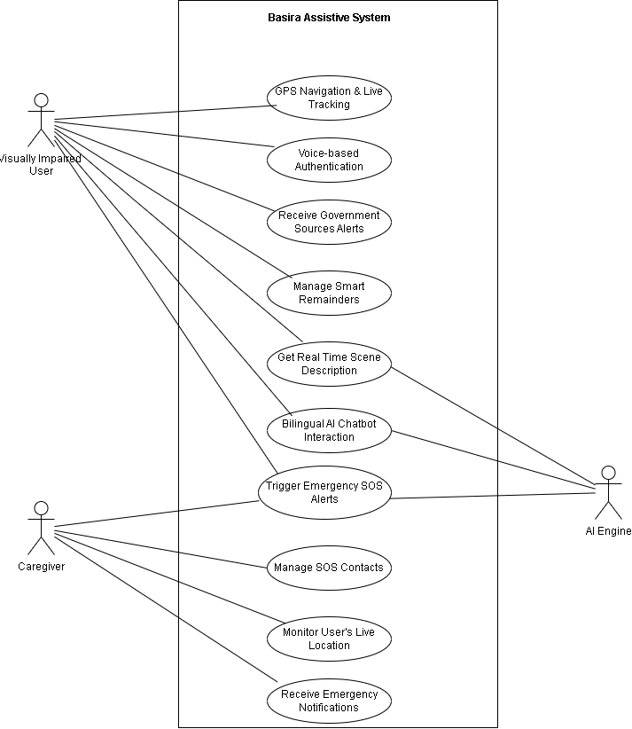

    - Admin-Side Use Case Diagram:
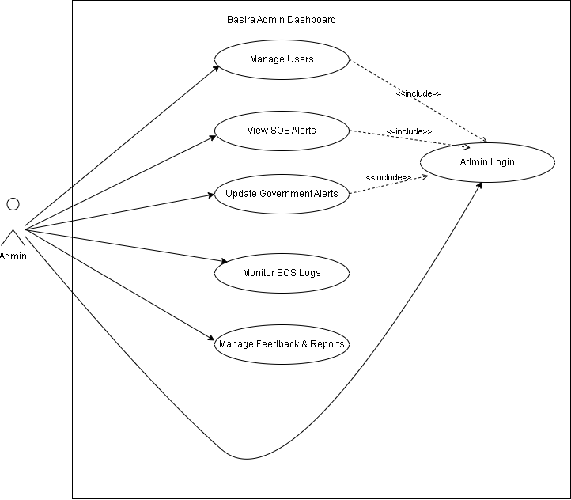

Fully Dressed Use Cases
While the diagram provides a visual overview, this section offers a "Fully Dressed" analysis of the most critical use cases identified. Each table describes the step-by-step interaction between the actors and the system, including preconditions and success scenarios.
Use Case 1: Get Real-time Object Detection
Field | Description
Use Case ID | UC-01
Use Case Name | Real-time object Detection
Primary Actor | Visually Impaired User
Secondary Actor | AI Services (YOLO Model)
Precondition | Camera permissions are active and the detection module is initialized
Main Success Scenario | 1. User activates the detection mode via voice command.  2. The system captures live video frames from the device camera.  3. The YOLO model identifies objects and obstacles in the frame.  4. The system announces detected objects via audio feedback
Post-condition | The user receives instant audio alerts regarding obstacles in their path.

Use Case 2: Bilingual Open-Source Chatbot
Field | Description
Use case ID | UC-02
Use Case Name | Interact with Open-Source AI Assistant
Primary Actor | Visually Impaired User
Secondary Actor | LLM Engine (Open-Source)
Precondition | Microphone access is enabled and network connectivity is available.
Main Success Scenario | 1. User activates the assistant and asks a question in Urdu or English.  2. The system identifies the language and sends the query to the LLM Engine.  3. The LLM Engine generates a contextually relevant response.  4. The system outputs the response in natural audio.
Post-condition | User's query is resolved using conversational AI reasoning.

Use Case 3: Trigger Emergency SOS Alert
Field | Description
Use case ID | UC-03
Use Case Name | Activate Emergency SOS Alert
Primary Actor | Visually Impaired User
Secondary Actor | Caregiver
Precondition | GPS is enabled and emergency contacts are stored.
Main Success Scenario | 1. User triggers SOS via hardware gesture or voice command.  2. System retrieves current GPS coordinates.  3. An automated alert with a location link is sent to the Caregiver.  4. System confirms the alert transmission via haptic pulse.
Post-condition | Caregiver is alerted to the user's location for emergency assistance.

Use Case 4: Admin Dashboard Authentication
Field | Description
Use case ID | UC-04
Use Case Name | Secure Admin Login
Primary Actor | System Administrator
Precondition | Admin credentials exist in the system database.
Main Success Scenario | 1. Admin enters credentials on the dashboard login portal.  2. System validates credentials against the secure database.  3. System redirects the admin to the management homepage.
Post-condition | Admin gains access to backend management features.

Use Case 5: User & Caregiver Management
Field | Description
Use case ID | UC-05
Use Case Name | Administer User Profiles
Primary Actor | System Administrator
Precondition | Admin is successfully logged into the system.
Main Success Scenario | 1. Admin accesses the 'User Management' module.  2. System displays a list of registered Blind Users and Caregivers.  3. Admin updates, approves, or suspends specific user accounts.  4. Database reflects changes across the mobile application.
Post-condition | The user database remains verified and secure.

Use Case 6: Update Resource Hub & Alerts
Field | Description
Use case ID | UC-06
Use Case Name | Manage Government Resource Hub
Primary Actor | System Administrator
Precondition | Admin session is authenticated and active.
Main Success Scenario | 1. Admin drafts an alert regarding local disability resources or welfare news.  2. Admin publishes the alert to the system backend.  3. System broadcasts a notification to the mobile application.  4. Mobile app converts the text alert into an accessible audio announcement.
Post-condition | Visually impaired users are informed of relevant localized updates.

Chapter 4

System Design

Chapter 4: System Design
This chapter provides a detailed blueprint of the Basira system's internal structure and technical framework. System design translates the analytical models into a technical reality, defining how the application’s components, data entities, and user interfaces interact to deliver real-time assistance. By utilizing various UML diagrams, we outline the architectural flow, database relationships, and behavioral transitions of the system. The goal of this chapter is to ensure that the development process follows a structured path, maintaining high performance, scalability, and reliability for the visually impaired end-users.

Architecture Diagram
The system architecture of Basira is based on a robust mobile-cloud framework. It illustrates the high-level interaction between the Flutter-based mobile application, the centralized Cloud Server, and external AI services. The diagram highlights how API requests flow from the user’s smartphone to the backend, which then coordinates with the Supabase PostgreSQL database and third-party APIs (like OpenAI for reasoning and Google Maps for location) to provide a seamless feedback loop.
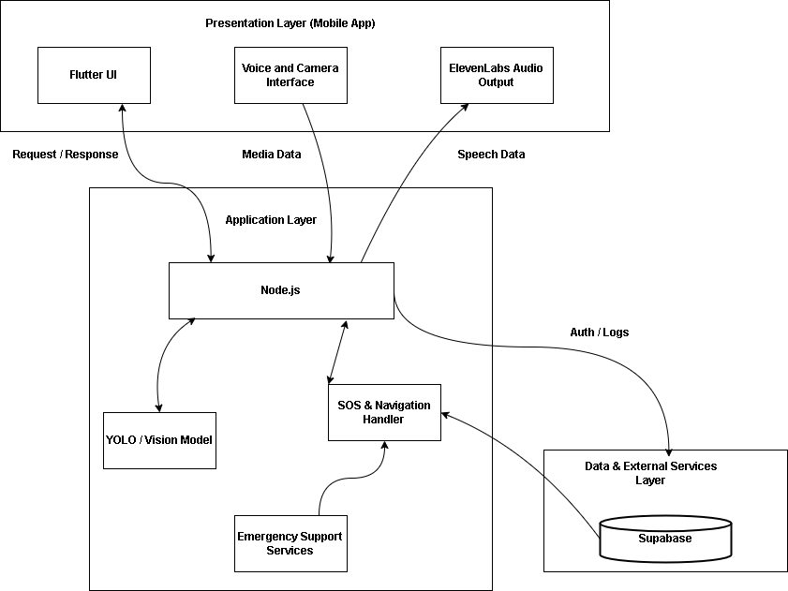

Domain Model
The Domain Model represents the conceptual classes and real-world entities within the Basira ecosystem. It identifies the primary relationships between the User, their assigned Caregivers, and the various modules like SOS alerts, Navigation logs, and Reminders. This model serves as the foundation for the system's logic, ensuring that all functional areas are interconnected without unnecessary complexity.
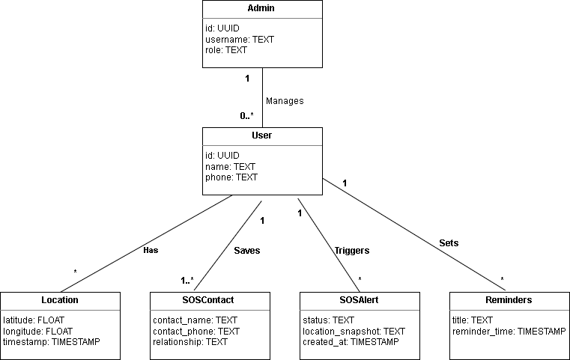

Entity Relationship Diagram with data dictionary
The ERD defines the logical structure of the Supabase database. It showcases how tables like Users, SOS_Contacts, and Chat_History are linked through primary and foreign keys.
- Data Dictionary:
  - Users Table: Stores unique UUID, name, email, and authentication details.
  - SOS_Alerts Table: Records the location snapshot, status, and timestamp of every emergency event.
  - Locations Table: Tracks the latitude and longitude history for the navigation feature.
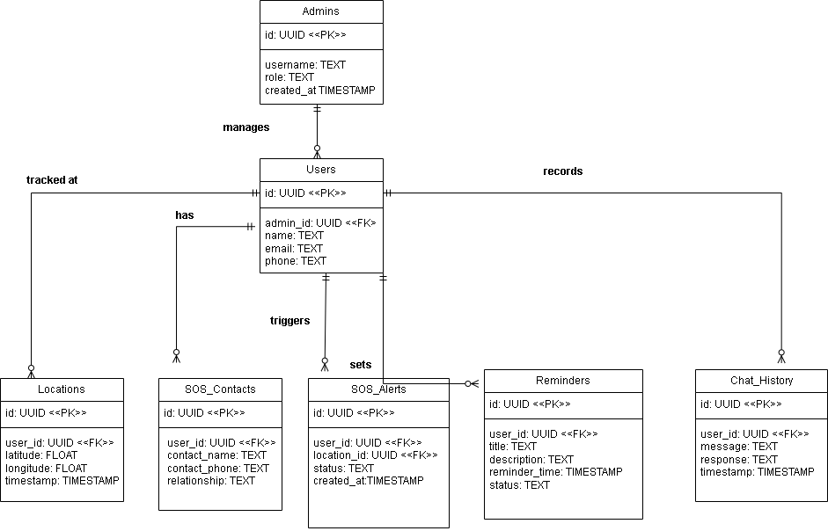

Class Diagram
The Class Diagram provides a static view of the system’s programming structure. It details the attributes and methods for core classes such as Navigation, Chatbot, and SOS. For instance, the Chatbot class includes methods like processMessage() and generateResponse(), which are essential for the bilingual interaction feature.
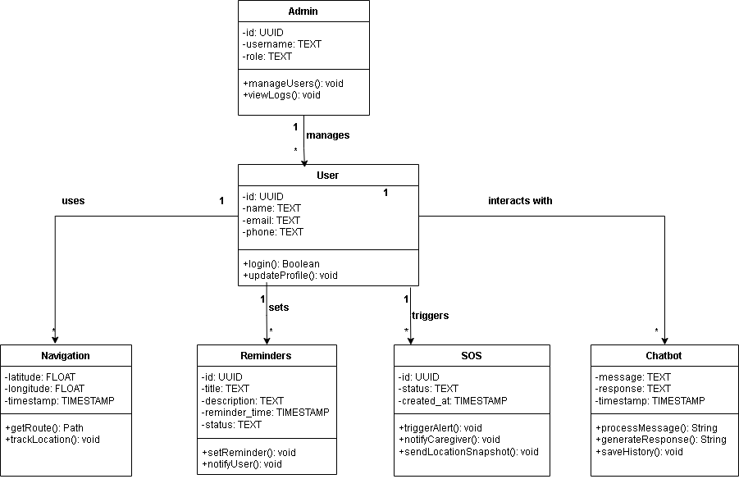

Sequence / Collaboration Diagram
The Sequence Diagram illustrates the step-by-step interaction for the "Scene Analysis" process. It shows the timeline of a message starting from the User capturing a scene, the image being sent to the Node.js backend, the YOLO engine detecting objects, and finally the TTS (Text-to-Speech) engine converting that data into an audio description for the user.
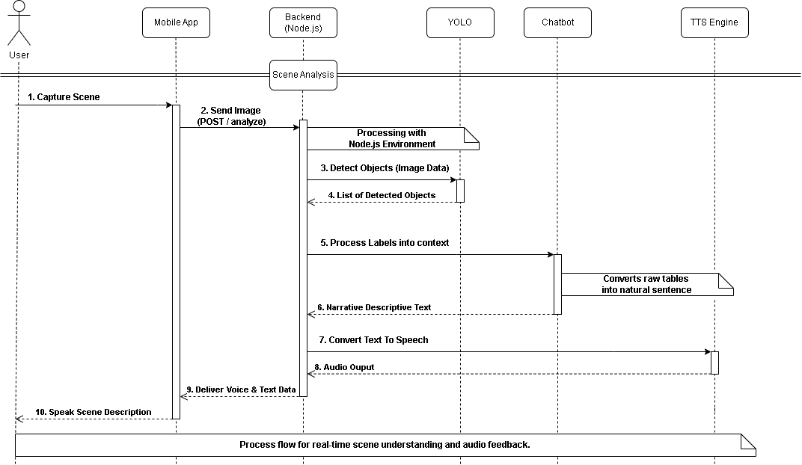

Operation contracts
Operation contracts define the logical state changes within the system. For the triggerSOS function, it specifies the mandatory pre-conditions and the resulting post-conditions to ensure data integrity during emergencies.

Contract Name | Description
Operation: | triggerSOS( )
Cross References: | Use Case: UC-03 (Triggering Emergency SOS)
Pre-conditions: | User is authenticated and emergency contacts are registered in the system.
Post-conditions: | 1. An emergency alert instance is created in the database.  2. Notifications are dispatched to registered caregivers.  3. User's current GPS location is recorded and shared.

Data Flow diagram [only if structured approach is used - Level 0 and 1]
The Level 0 DFD (Context Diagram) shows the overall flow of information between the user and the Basira system. It depicts how voice/camera inputs are transformed into audio/navigation outputs by interacting with external APIs and the internal Supabase database.

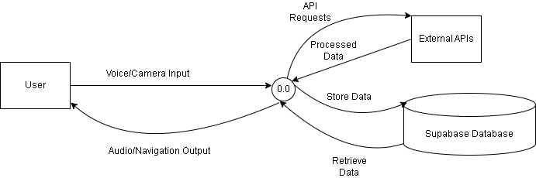

Chapter 5

Implementation

Chapter 5: Implementation
This chapter outlines the technical realization of the Basira application, detailing the transition from design models to a functional system. It covers the core algorithms, the integration of specialized libraries, and the cloud infrastructure used to host the backend services. Furthermore, this section discusses the development tools, coding standards, and version control mechanisms adopted to ensure the application is robust, scalable, and maintainable for real-world assistive use.

Important Flow Control/Pseudo codes
The core logic of Basira revolves around synchronized data processing between the camera and the AI engines. The following pseudo-code describes the real-time object detection and audio narration flow:
Algorithm: Scene-to-Speech Processing
- Initialize Camera stream and YOLO engine.
- Capture frame at 0.2s interval.
- Perform inference using YOLO to identify objects and distances.
- If object distance < 1 meter:
  - Trigger urgent haptic feedback.
  - Generate immediate audio alert (e.g., "Obstacle ahead").
- Else:
  - Send labels to LLM for context (e.g., "A wooden chair is 3 meters away").
- Convert text to speech and Output via system speaker.

Components, Libraries, Web Services and stubs
To achieve high performance, the system utilizes several modern libraries and services:
- Flutter & Dart: For building the cross-platform mobile interface.
- TensorFlow Lite: Used for running the YOLO model locally on the iPhone 11 to minimize latency.
- Supabase SDK: Handles real-time database synchronization and user authentication.
- OpenAI API: Acts as the reasoning engine for the bilingual chatbot.
- Eleven Labs / Google TTS: Provides high-quality natural voice synthesis.

Deployment Environment
The Basira system is engineered for maximum accessibility, ensuring it can operate on a wide range of mobile devices without requiring specialized high-end hardware.
- Client-Side Hardware: The application is compatible with standard mid-range mobile devices. It utilizes optimized on-device processing to handle camera input and navigation tracking efficiently, making it accessible to a broader user base within the visually impaired community.
- Cloud Infrastructure: A Node.js runtime environment is used on the server side to handle the heavy computational tasks like complex AI reasoning, which reduces the processing burden on the user's local device.
- Data Tier: Supabase Cloud (PostgreSQL) provides a secure and lightweight data persistence layer that ensures consistent performance regardless of the user's specific hardware specifications.

Tools and Techniques
The implementation of Basira utilized a variety of industry-standard tools and development techniques to ensure system stability and performance.
- Flutter SDK: The primary framework used for developing the reactive user interface and managing cross-platform hardware interactions.
- Node.js & Express: Utilized for building the server-side logic and managing high-concurrency API requests from the mobile client.
- Postman API Suite: Employed for rigorous testing of RESTful endpoints, ensuring low latency and data integrity before integration.
- Figma Modeling: Used for designing the architectural frameworks, DFDs, and system interaction diagrams presented in this documentation.

Best Practices / Coding Standards
To ensure the Basira system is maintainable and meets software engineering standards, the following practices were implemented:
- Separation of Concerns (SoC): The architecture is strictly divided into Presentation, Business Logic, and Data layers.
- Asynchronous Programming: Utilized to prevent UI freezing during heavy AI processing or network requests.
- Defensive Programming: Extensive input validation and error-handling blocks are integrated to manage potential API or sensor failures.
- Standardized Naming Conventions: Consistent use of descriptive naming for variables and functions to enhance code readability.

Version Control
A centralized Version Control System (VCS) was employed to manage the project’s codebase throughout the development lifecycle. This approach allowed for:
- Change Tracking: Maintaining a detailed history of all modifications, enabling easy rollbacks if required.
- Branching Strategy: Developing major features (like the AI Chatbot or SOS module) in isolated branches before merging them into the stable version.
- Collaboration: Synchronizing work between development modules to avoid code conflicts and ensure a unified final product.

Appendices

Appendix A: Information / Promotional Material
[Paragraph Text 12 pt, Calibri, 1.5 Line Spacing, Justified]
[Between 4 to 8 lines describe what is this appendix all about]

  - Broacher

  - Flyer

  - Standee

  - Banner

  - First Level heading [16 pt, Calibri, Bold, Left aligned]
[Paragraph Text 12 pt, Calibri, 1.5 Line Spacing, Justified]

    - Second level heading [14 pt, Calibri, Bold, Left aligned]
[Paragraph Text 12 pt, Calibri, 1.5 Line Spacing, Justified]

      - Third level heading [12 pt, Calibri, Bold, Left aligned]
[Paragraph Text 12 pt, Calibri, 1.5 Line Spacing, Justified]

Appendix [no.]: Appendix Title
[Paragraph Text 12 pt, Calibri, 1.5 Line Spacing, Justified]
[Between 4 to 8 lines describe what is this chapter all about]

  - First Level heading [16 pt, Calibri, Bold, Left aligned]
[Paragraph Text 12 pt, Calibri, 1.5 Line Spacing, Justified]

    - Second level heading [14 pt, Calibri, Bold, Left aligned]
[Paragraph Text 12 pt, Calibri, 1.5 Line Spacing, Justified]

      - Third level heading [12 pt, Calibri, Bold, Left aligned]
[Paragraph Text 12 pt, Calibri, 1.5 Line Spacing, Justified]

Reference and Bibliography

Reference and Bibliography

[1] Ultralytics, "YOLO 26 NVM: High-Precision Real-Time Object Detection and Computer Vision Framework," [Online], 2026.
[2] Google, "Flutter SDK Documentation: Building Accessible Cross-Platform Applications for Visually Impaired Users," [Online], Available: https://docs.flutter.dev/, 2026.
[3] Supabase, "PostgreSQL Database and Real-time Backend-as-a-Service (BaaS) Documentation," [Online], Available: https://supabase.com/docs, 2026.
[4] OpenWeatherMap, "Weather API Documentation for Real-time Environmental Data Integration," [Online], 2026.
[5] Google Maps Platform, "Directions and Geolocation API Documentation for Pedestrian Navigation," [Online], 2026.

